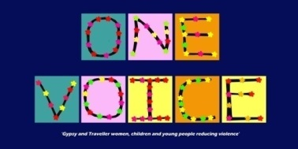

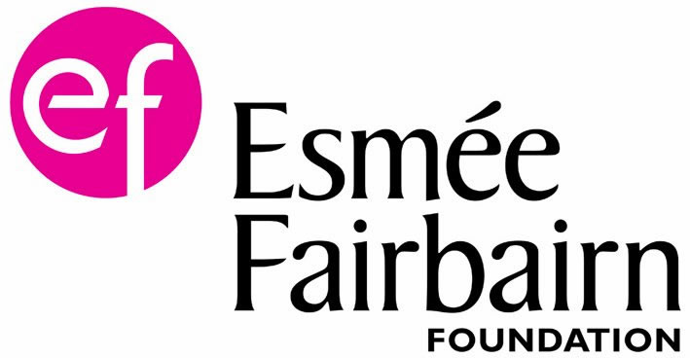

One Voice for Travellers Limited

One Voice 4 Travellers Limited, a community based charity, are proud to announce that having received funding from Esmee Fairbairn we able to establish for the first time in history a national 3rd Party Domestic Abuse Reporting service specifically for the Gypsy Traveller and Roma community. This project will allow the reporting domestic violence, and abuse data base to be set up. This project is the result of a successful pilot project undertaken in Norfolk together with One Voice 4 Travellers who has over fifteen and years of experience of working within this area of need and our Norfolk partners where able to gather the first data relating to GTR women and girls experiences of domestic abuse. This project will build on that valuable work on a national level by working in partnership with survivors, and established partners supporting GTR women and girls across England

Together we will stop this violence and abuse

For more information:
Write to:
One Voice 4 Travellers Limited, 3A Country Park, Jubilee Lane, Marshland St James, Wisbech PE14 8JD

E-mail:
Onevoice4travellers@hotmail.com

Telephone: 01945 430 724

We do not have someone in the office all the time, so if you ring and we are not able to answer, please leave a message and we will return your call.

Company limited by guarantee in England and Wales No 6350995 Charity Number 1132377

